AMAPPS Seabird Survey Protocols
Adapted to SeaScribe v 1.2.1

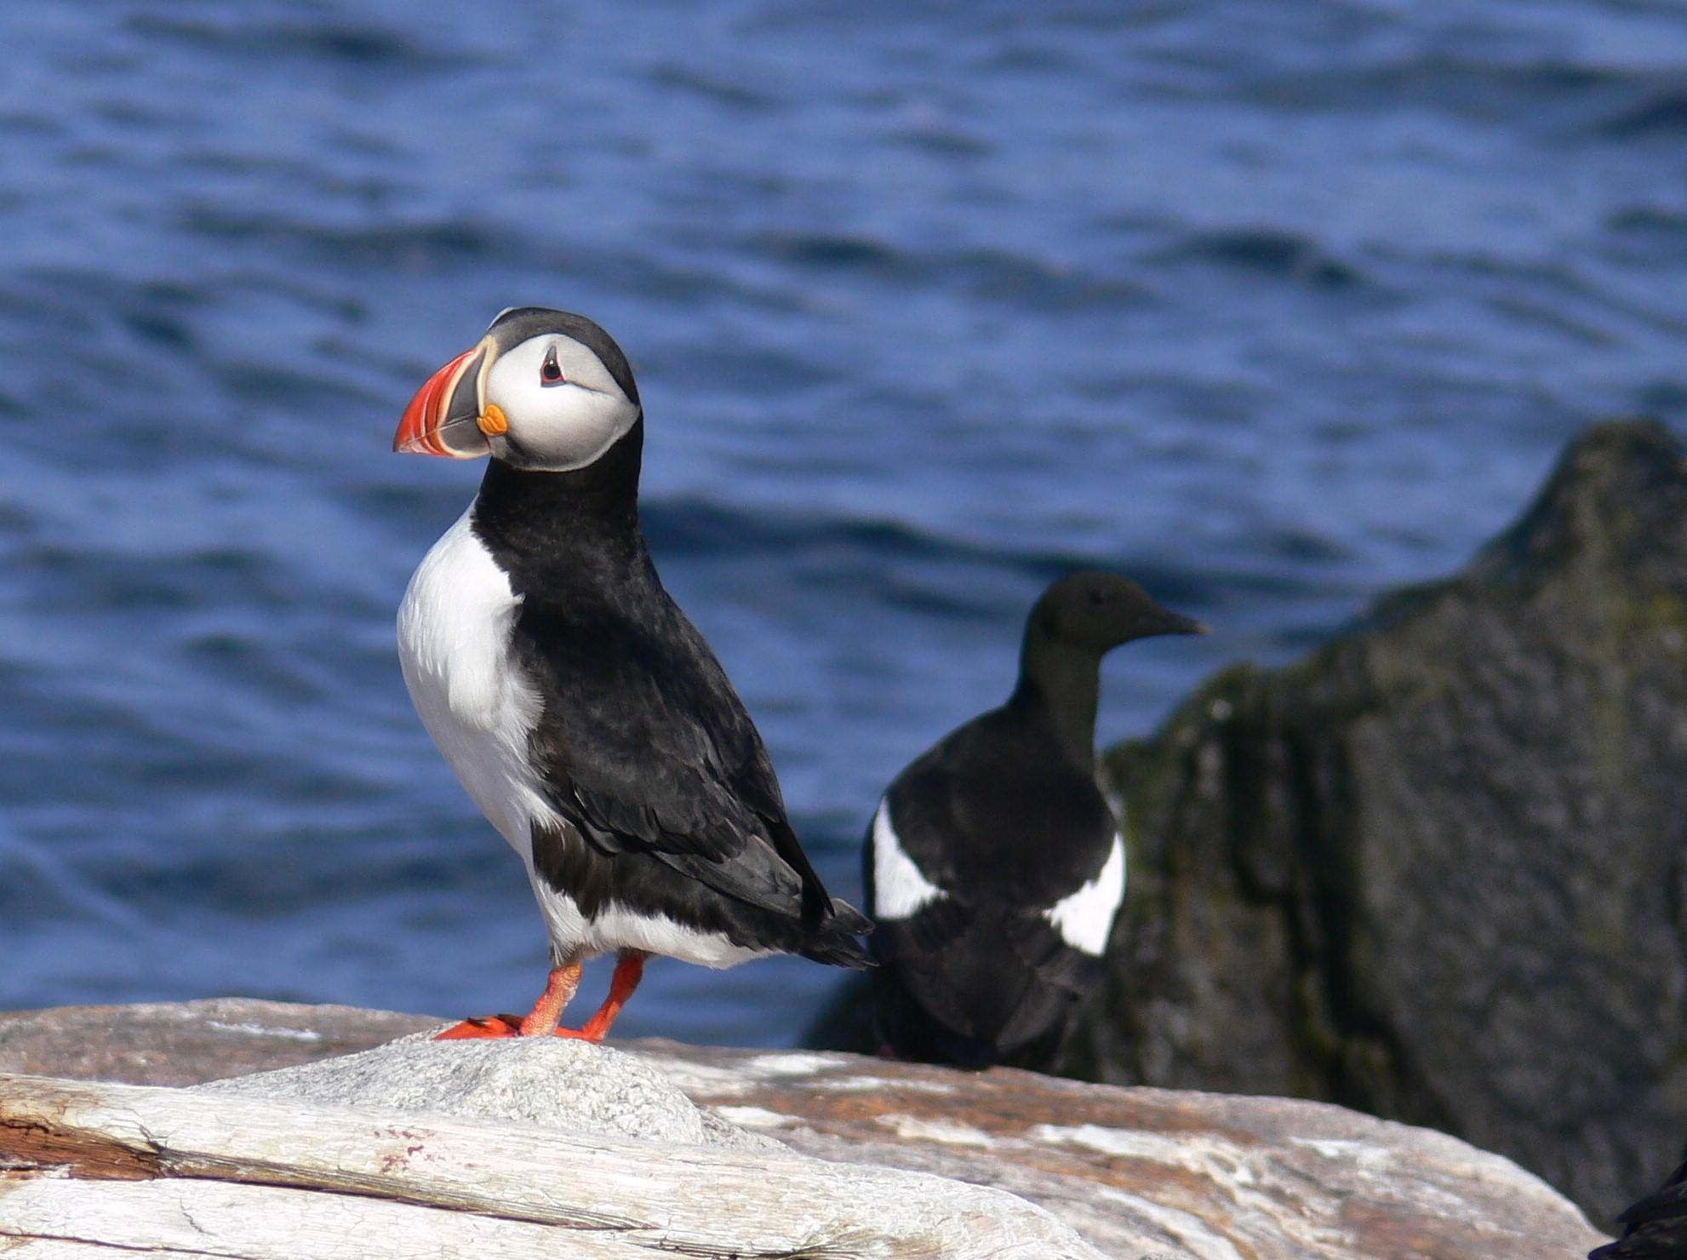
Photo Credit: Nicholas Metheny,

A summary of seabird protocols and data collection procedures used on NEFSC/AMAPPS surveys

April 2019

Introduction:

This manual provides background information and instructions on data collection procedures in the field and data entry onto a tablet for pelagic seabird distribution and abundance surveys. The protocol is based on a standardized 300 meter strip transect survey widely used by agencies in North America and Europe (e.g., Anon 2011, Ballance 2011; Tasker 1984); and much of the background material found in this manual come from previous iterations of this data protocol (Force 2014; Anon 2011). The software used is SeaScribe (V 1.2.1), a data collection program developed in collaboration with the Bureau of Ocean Energy Management (BOEM), Biodiversity Research Institute (BRI), and Tilson Tech. It is designed to collect real-time data during at-sea transects of marine wildlife sightings in concert with a multitude of various adaptable data fields to be customized by a given project’s survey parameters. The program is driven by touch screen selection, as well as diagramming and mapping of data input via internal GPS logging and on-line (or offline) map caches.

Strip Transect Methodology
The primary objective of the seabird survey is to determine the distribution and abundance of seabirds in the pelagic environment. The survey strip width is 300 meters, which means you should monitor the area of ocean on one side of the ship (the side with the best viewing conditions), from bow to beam, out to 300 meters (a 90 degree quadrant). All the birds seen within this area are counted.
Observers should be aware of the assumptions associated with strip and line transects methods. The most important assumption is that ALL birds within your sampling zone (the 300 meter strip) are detected. Accordingly, you must focus your attention on this area of ocean so that you will be able to detect all birds. Most birds will be detected with the naked eye; however, use binoculars as needed to scan the perimeter of the 300 meter survey zone. This is particularly relevant with diving birds, such as alcids and loons, which frequently dive in response to approaching vessels. Therefore, you should frequently scan the count zone along the trackline in order to search for birds that could be actively avoiding the ship by diving rather than flying.
Observe from whichever side of the flying bridge is best, taking account of glare, wind etc. You should not hesitate to switch your effort to the other side of the ship if viewing conditions become better there.
Accurately estimating the 300 meter distance of your zone is another important assumption. Determining this will be accomplished using range finders, the specific measurements for the construction of the range finder will depend upon the survey platform and individual observers; the translation of survey specific parameters for ranger finder construction can be found under “Tools” and “Distance Estimation Guide” within the SeaScribe program.Be sure to check yourself several times a rotation or whenever you feel is necessary to help train your eye on distances between 0 and 300 meters. If distance training for the marine mammal observers is included in the cruise plan, seabird observers should work with the Chief Scientist to ensure many distances at and within 300 meters are performed.
You should only record data using the strip transect method when the ship is "on effort", that is when it is following a pre-determined track laid out for sampling the area being surveyed, or direct lines between oceanographic sampling stations.
You should end the current transect observation period and begin anew (the same or new trackline depending on the situation) each time one of the following events occurs:
- At the end of a designated transect line, or arrival at a sampling station, and then resuming the survey.
- At a significant course change (15 degrees or greater)
- At breaks in effort due poor environmental conditions such as fog, rain, squalls, etc.
- Where ship speeds falls below 6kts and then resumes at 8kts

Notes on Procedures:
Equipment, Data Collection, General Procedures
Observations are made from a station on the flying bridge (avoid observing from the bridge because effectively scanning the survey strip is often severely compromised, and the internal gps will not function that well). Basic equipment on board includes:
- Data entry Tablet
- Seabird guides
- Pencils, paper, and assorted notebooks
- Flying bridge observer station (normally a table and/or chair)
Seabird data will be recorded on a tablet. Data will be checked and exported from the database nightly, and backed-up.
Generally, data is collected from 0600 to 1800 hours, or sunrise to sunset, depending on project requirements. Two seabird observers will maintain a two hour single-observer watch rotation, or variations thereof; however, maximum watch duration shouldn’t exceed 2 hours. In extreme high density areas, two seabird observers can be on watch simultaneously, with one conducting the observations and the other recording data (be sure to record when dual effort occurs). Because the strip width is 300 meters alongside the ship, it will be possible to collect good bird data under conditions which preclude mammal observations. Bird observations are possible in seas up to Beaufort 7, in light fog, and in light rain. Your decision as to whether to continue observations or not will also be affected by the Chief Scientist’s decision regarding the ship’s course while the (i.e. continuing on the trackline, or running a weather tack while waiting for conditions to improve).
Additionally, there are times when the ship will have temporary limitations that affect speed. The target speed for the seabird (and mammal) survey is 10 to 12 knots through the water. However, should the speed fall below eight knots, please be sure to comment on this, as these data may be questionable for absolute abundance estimates. If the ship’s speed falls below 6 knots, effort should be suspended.
Generally, line transect surveys for marine mammals are conducted in either passing or closing mode. Passing mode entails obtaining as much data as possible on species, group size and composition while continuing underway. Conversely, closing mode involves breaking off the trackline whenever needed to close on animals in order to confirm identification of cryptic species, and to better estimate group size and composition. When this occurs, seabird observers will temporarily need to go off effort. Seabird observations should resume once the ship has returned to the trackline and reached appropriate speed (generally this will coincide with the mammal observers also going back on effort). (NOTE: if there were birds aggregated above the marine mammals, you should wait to begin the next transect until the ship is out of this aggregation. A few minutes are generally sufficient).
All of the data collected on the ship are the official property of NMFS/NOAA/NEFSC. Should you wish to access any part of them for dispensation, analysis, or use of any kind, please discuss your intentions with the Principle Investigator/Chief Scientist.

Getting Started with SeaScribe:
*Before starting to collect data go to settings and under GPS make sure the “Automatic GPS Polling Interval(s)” is set to 300; this will space out the interval of time Seascribe will grab your location to add to the data.
- Opening SeaScribe to the Main Menu, select Start New Survey.
- On the Start New Survey Screen, name the survey. The usual survey naming nomenclature is the NOAA ship’s abbreviation followed by the last two digits of the year, and then the two digit survey number of the year for that ship. For example, the survey name for a project heading out on the Henry Bigelow, in 2019, on its third survey mission, should be HB1903.
    - Note, that it maybe easiest to add the date to the end of the name to designate each day of the survey to better organize and analyze after exporting and post-processing the data. Eg. HB1903-4/22
- Data collection Mode should be Standard; rarely, if ever, should Audio Only Observations be used for vessel based surveys.
- The Methodology should be preloaded on to the SeaScribe tablet, and you should select the AMAPPS protocol. The Methodology allows for the creation of project specific protocols, and data fields collected. For the purposes of work done for the NEFSC the AMAPPS methodology suffices.
  - If the AMAPPS Methodology is not present you will have to create it independently; see the Appendix
- Number of Observers should be two, and only in rare instances is there a single bird observer aboard. Following this field put in the pertinent information for each observer, including name, expertise level, and email address.
- The Survey Platform is the name of the vessel you are surveying from; if the vessel is not already in the database, please add it.
- Select the appropriate region; for NEFSC and SEFSC the North Atlantic Ocean should be selected
- The Species List is separated into Atlantic and Pacific Species; select Atlantic Species.
- Under Ancillary Fields, the added fields should be already selected per the Methodology chosen.
- Next, select Check GPS; if the GPS is receiving a good signal the bar should turn green. Of note, currently this version of SeaScribe relies solely on the internal GPS of the tablet, and there doesn’t appear to be any way of syncing an external, blue-tooth enabled, GPS unit with the program.
- Select Start Transect, to begin collecting observer sightings.
- Transect Name should follow a numerical order starting from one and going upward through the survey. However, if on a marine mammal survey be sure to number the transects the same way as the marine mammal team.
- Select the Observer starting the watch from the drop down menu
- Select the Position observations will be conducted from (Starboard/Port)
- Select the Beaufort Sea State , Visibility, and Observer Conditons. Of note, observer conditions are based on a scale of one to five as follows:
  - 1 Conditions extremely bad
    - --Storm-Petrels, Phalaropes, and small alcids cannot reliably be detected to 100 m
    - --All individuals of all other species cannot reliably be detected to 200 m
  - 2 Conditions poor
    - --All Storm-Petrels, Phalaropes, and small alcids visible to 100 m
    - --All individuals of all other species visible to 200 m
  - 3 Conditions fair
    - --All Storm-Petrels, Phalaropes, and small alcids visible to 200
    - --All individuals of all other species visible to 300 m
  - 4 Conditions good
    - --All individuals of all species visible out to 300 m
  - 5 Conditions excellent
    - --All individuals of all species visible out to 300 m +
- Check to see the Current Date and time is correct (if not, then correct the time zone under settings) and then select Start Recording Observations

Recording Data:
- In the Species field type in the acronym for the species sighting. Note if you do not know the code, type in the common name and the field will prompt you with a list of suggestions as you type in the common name. Further, the Quick Species field should start populating with the abbreviations of frequent species seen to allow for quicker entry of species identification.
- Enter the number of animals seen in the Count field; there is a hotkey of “1” for single animals seen.
- In the Distance field enter a single digit number that represents the distance from the ship to the bird when you first saw it (or when it first enters your survey strip). Use the following codes:
  - 1 - 0 - 100 m from the ship
  - 2 - 100 - 200 m " " "
  - 3 - 200 - 300 m " " "
  - 4 - outside of this area
    - Note that a code of "4" applies to a bird closer than 300 m to the ship, when it is on the opposite side from the side you are surveying on.
    - Distance code 4 is included primarily so you can record RARE birds and FLOCKS of birds greater than SEVEN even when they do not enter our 300 m strip.
- In the Degree field, enter the bearing of the sighting relative to the ships bow.
- Note a sighting on the Port side will have a degree bearing between 270 and 0: and a sighting on the Starboard side will have a degree bearing between 0 and 90.
- Under Behavior, select the appropriate designation from the drop down menu; alternatively there are hotkeys for common behaviors in the Quick Behavior field you can select.
- Under the Direction field select the cardinal direction the sighting was moving relative to the boat, with the bow of the boat being North and the stern being South (if it was moving in a direction; select no direction if the behavior is Sitting or Milling).
- In the Age field select the appropriate category for the sighting. If the age is Unknown leave this field blank, and enter Unknown in the spreadsheet for this entry post-processing
- In the Plumage field select the appropriate category for the sighting; if the animal was not an adult leave blank, and enter and enter Unknown in the spreadsheet for this entry post-processing.
- Under Sex eneter gender of the animal, if known; if not select Unknown.
- The Link With field is a work in progress; it allows you to link a new sighting with a previous sighting, but you would have to go into the data editing section to link the previous sighting with the new sighting. In its current version, its best to ignore the Link With field and use the Association data field that can be found as an Ancillary data field.
- Record any special notes in the Comment field pertaining to the sighting
- In Flight Height select from the range of height intervals found in the drop down menu.
  - Note, N/A applies to birds sitting in the water, and non-avian animals recorded in the database.
- In the Association field select from the drop down menu the appropriate category.
  - If a sighting is associated with other avian species select the option: “Associated with other species feeding in the area” even if feeding was not occurring
  - Also clarify in the Comments field which species this sighting was associated
    - E.g. w/comu and atpu
  - Note, in post-processing of the data all species associated in one group will have to be sure the lat, long, distance, and bearing data are all the same for all species seen in the group.
- In the Events field:
  - Select Flock for groups of birds greater than seven, seen outside the first three zones.
  - Select Cumulative for when density of birds are so great that recording individual birds or single groups of birds become impractical to keep up with real-time data entry.
    - In these situations, it will be necessary to count birds in blocks (as groups of 10's for example) and enter these numbers periodically or at regular intervals.
    - The critical data to record in these cases are Species and Count for each time period. You “may” record accurate data for remaining fields, but if time does not allow for this, use Distance code 3 (you should not count any birds if they are farther than 300 meters from the ship), leave Behavior blank and enter Other in post-processing, and note in the comments field that for this situation you are using this code to indicate that no data on behavior were recorded), and use Unknown for Plumage, Association, Age, and Sex (in post processing add Unknown in for these sightings in the fields Plumage, Association, and Age). Use code N/A for Flight Height to indicate that no flight height data were recorded.
    - Because this project will generally be designed to survey birds in oceanic areas (i.e. where bird densities are relatively low) you should rarely need to use this Event option.
- Then select Save to transfer the sighting to the spreadsheet; also a dot should appear on the map as well.
  - Note, the dot will grower bigger if any given area has a large amount of sightings.

Changing Conditions, Observers, or Writing a Comment:
To change environmental conditions or to switch out observers:
- Enter the code COCH into the Species field and hit the Count hotkey of 1.
- Scroll down to the bottom of the data entry screen to where the observer and environmental conditions are located and change as needed.
- Select Save to complete Observer/Condition Changes
To write a comment without having to enter a sighting:
- Enter the code NONE into the Species field and hit the Count hotkey of 1.
- Scroll down, and write the comment in the Comments section.
- Select Save
Ending and Starting a New Trackline:
- To end recording observations for a given trackline, simply select Stop.
- You will be prompted for confirmation to stop observations, select OK.
- Then record any comments you feel necessary about the end of the track line, and select Stop Transect.
- You will be transferred to the Main Menu screen, form there select, Existing Survey, and then select that day’s survey.
- Below “Select a Survey,” a row of buttons should have become highlighted; select Start New Transect and then follow the directions from step 2 given under “Getting Started with SeaScribe.”
  - Note if you are resuming effort on the same trackline, SeaScribe will not allow you to continue recording on the previously “ended” transect.
    - What you will need to do when starting a new transect, is to name the new trackline as an alphanumeric, indicating the number of the trackline you are continuing surveying on followed by the letter A. If you start and “end” on a trackline multiple times, continue down the alphabet in the naming of tracklines. E.g. 2, 2a, 2b, 2c, 2d, etc.
    - When you are post-processing the trackline data, you will need to combine these separate tracklines under one transect name.
- When ending observations for the day follow the directions to end the trackline and you are done.

Exporting/Backing Up Data:
When you are ready to export/back-up the day’s data:
- Select Existing Surveys from the Maine Menu
- Select the Day’s Survey Data, E.g. HB1903 4-21
- Below “Select a Survey,” a row of buttons should have become highlighted; select Submit.
- You will be prompted to select Export Parameters, select CSV
- Then select export destination Email
  - Note, an email account has to be set up on the native email app for the Email option to show as an option for export
  - Note, the DropBox option does not work with this version of SeaScribe if using an Apple iPad; it should however work with an Android based OS.
- Select Export
- Check your email, and download the csv file to your computer.
- To process data, simply open the csv file in your spreadsheet program
- You will notice that there is a space between each data entry that makes filtering and sorting impossible at this point. You will have to delete every other row.
  - To do this, go over to on of the “Audio” data columns at the far right end of the spreadsheet.
  - Enter a “1” in every empty cell under one of the “Audio” data columns
  - Select to filter that column, and filter for “1”
  - Highlight all the rows that appear for the entire spreadsheet
  - Right click, and press Delete Rows
- You will also notice the data in the raw format is sorted from last to first.
  - To change this, select the Observation ID data column
  - Go up to the tool bar and select the Descending icon
  - A prompt will open, select Expand the Selection; this will keep the data appropriately associated.
  - Select Sort
  - The raw data will have approximate 46 data columns; for the purposes of this survey, below is a tentative list of data columns that can be deleted before finalizing the data. Note: Others maybe added or removed from this list.
      - Survey ID
      - Transect ID
      - Transect Start
      - Transect End
      - Observation Type
      - Species ITIS#
      - Behavior Description
      - GPS Altitude Accuracy
      - GPS Altitude
      - Num Photo
      - Photo List
      - Num Audio
      - Audio List
References:

Anonymous. 2011 Seabird Survey Instruction Protocol. Seabird distribution and abundance, Summer 2011. NOAA RV Henry B. Bigelow. Northeast Fisheries Science Center.

Ballance, Lisa T. 2011. Seabird Survey Instruction Manual, PICEAS 2011. Ecosystems Studies Program Southwest Fisheries Science Center, La Jolla, California.

Bowditch, N. 1966. American Practical Navigator, U.S. Government Printing Office, Hydrographic Office Pub. No. 9, 1524 pages).

Force, Mike. 2014 Seabird Survey Instruction Protocol. Seabird distribution and abundance survey protocols, Summer 2014. Northeast Fisheries Science Center.

Tasker, M.L., Hope Jones, P., Dixon, T. and Blake, B.F. 1984. Counting seabirds at sea from
ships; a review of methods employed and a suggestion for a standardized approach. Auk
101: 567 – 577.

Appendix

How to Format the AMAPPS Methodology if it’s Not On Your Device

- Open SeaScribe, Select Tools, then select Manage Data
- Select Edit Ancillary Field
  - You will need to create three new Acillary Fields, Flight Height (there is one pre-existing Flight Height, but we use blocked interval heights), Events, and Observer Conditions

- Flight Height Ancillary Field
  - Select New
  - Enter the Field Name as Flight Height
  - Under Frequency, select Each Observation
  - Select a Sort Order of 1
  - Under Input Control, choose “Select (from a list of choices)”
  - Under # Select Options, select 8
  - Under Select Option, just number them 1 through 8, before each Text data field
  - Input the following in descending order in the Text field
    - 0-2m
    - 2-10m
    - 10-25m
    - 25-50m
    - 50-100m
    - >200m
    - N/A
  - Then click Save

- Events Ancillary Field
  - Select New
  - Enter the Field Name as Events
  - Under Frequency, select Each Observation
  - Select a Sort Order of 3
  - Under Input Control, choose “Select (from a list of choices)”
  - Under # Select Options, select 2
  - Under Select Option, number them 1 and 2, before each Text data field
  - Input “Flock” in the Text box under ID 1
  - Input “Cumulative” in the Text box under ID 2
  - Then click Save

- Observer Conditions Ancillary Field
  - Select New
  - Enter the Field Name as Observer Conditions
  - Under Frequency, select Change at Intervals
  - Select a Sort Order of 3
  - Under Input Control, choose “Select (from a list of choices)”
  - Under # Select Options, select 5
  - Under Select Option, number them 1 through 5, before each Text data field
  - Text box under ID 1 enter 5
  - Text box under ID 2 enter 4
  - Text box under ID 3 enter 3
  - Text box under ID 4 enter 2
  - Text box under ID 5 enter 1
  - Then click Save

- Navigate back to the Maine Menu
- Click on Start New Survey
- Select the “+” beside the Methodology data field
- Enter AMAPPS as the Methodology Name
- Under Transect Type, select Fixed width
- Under Counting Methodology, select Continuous
- Select One Side, under Counting Performed On
- Click on Ancillary Fields and it should take you to a list
  - Select Association, Flight Height (remember not to select the one with the meters abbreviation beside it), Events, and Observer Conditions
  - When those fields are highlighted select “ > ” to add it to the right column of Selected Ancillary Fields
  - Select Save
- This takes you back to the New Methodology page, select Save again

Congratulations, you have just created the AMAPPS Methodology on your device!

